Bidirectional high frequency isolation ACDC module（20kW/15kW）

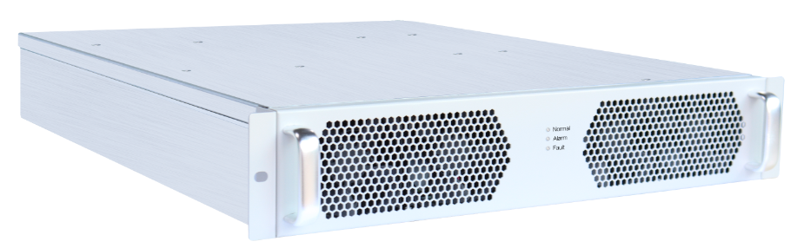

【Abstract】
V2G (Vehicle to Grid),Its core idea is to realize the bidirectional between EV and Grid，use the energy storage of EV as a supplement to the grid and renewable energy;V2L (Vehicle to Load),EV with the bidirectional charging and discharging batteries can be used as mobile energy storage to supply grid for 220 or 380V AC loads, which are equivalent to large mobile power banks.
V2G is widely used in energy storage, battery capacity, emergency power supply, equipment aging and many other fields. It is the first choice for the energy bidirectional flow application industry.

【Highlight】
Safe and reliable
•High-frequency isolation for higher safety
•DSP+CPLD full digital control
•Multiple security protection

Flexible configuration
•Modular design for easy maintenance
•Support multi-module parallel expansion
•The system has on-off-grid switching function

Smart and friendly
•Ultra wide voltage range
•Intelligent fan speed regulation to reduce power consumption and noise

Low cost
•Compared with the traditional bidirectional power supply scheme, the power frequency transformer is saved, and the system cost is low

【Application】
•Energy storage (EV energy storage V2G)
•Energy storage (battery cascade utilization)
•Battery composition and capacity
•DC power aging

【Technical parameter】
Product name |  | Bidirectional high frequency isolation ACDC module
Product model |  | BIM75040 | BIM300100
Charge
AC side parameter | Rated grid voltage | 400Vac（380/400/415Vac）
AC side parameter | Grid voltage range | 304Vac～485Vac
AC side parameter | Grid voltage frequency | 50/60 ±5% (50Hz/60Hz self-adapting)
AC side parameter | AC side | 3L+PE
AC side parameter | AC input current | ≤38A | ≤29A
AC side parameter | Power factor | ≥ 0.99 , full load
AC side parameter | THD of Current | < 3% , full load
Battery side parameter | Voltage range | 60～750VDC , Rated voltage 500VDC | 40～300VDC , Rated voltage 150VDC
Battery side parameter | Output current | 40A | 100A
Battery side parameter | Rated power | 20kW | 15kW
Battery side parameter | Efficiency | 95% max （Using SiC）,94%（Using Si）
Battery side parameter | Voltage regulation accuracy | ±0.5%
Battery side parameter | Steady flow accuracy | ±1%
Battery side parameter | Ripple factor | <1%Vo
Discharge
Battery side parameter | Voltage range | 60～750VDC , Rated voltage 500VDC | 40～300VDC , Rated voltage 150VDC
Battery side parameter | Output current | 40A Max | 100A Max
AC side parameter | V2G（grid discharge）
AC side parameter | Grid voltage range | 304Vac～485Vac
AC side parameter | Grid voltage frequency | 50/60 ±5% (50Hz/60Hz self-adapting)
AC side parameter | Rated power | 20kW | 15kW
AC side parameter | Efficiency | 95% max（Using SiC）,94%（Using Si）
Other properties
Protect function | OV protection | Have
Protect function | OC protection | Have
Protect function | SC protection | Have
Protect function | OT protection | Have
Other parameter | Operating temperature | -30～70 ℃ , 55℃ above output power derating
Other parameter | Storage temperature | -40～75 ℃
Other parameter | Noise | <60dB
Other parameter | Dimension | 442*575*86mm (W*H*D)
Other parameter | Weight | 19Kg | 15Kg
Other parameter | Protection | IP20
Other parameter | Type of cooling | Intelligent speed regulation, forced air cooling
Certification | EMC | 《GB/T 34120-2017》《GB/T 34133-2017》  《NB/T 33001-2018》《NB/T 33008-2018》

